**Student’s Project**

**MOROCCO**



**Gender Equality and Equity in Children’s Education**

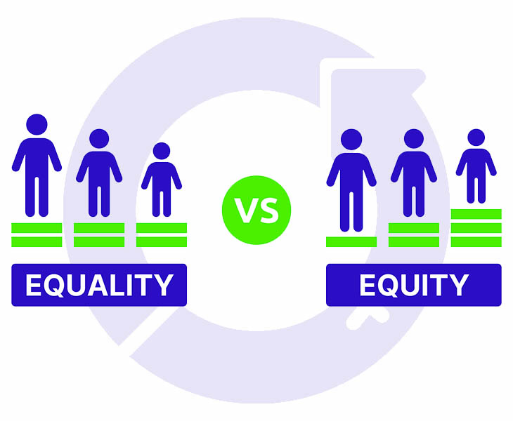

**The researcher : Meryeme Essaissi**

Supervised by : Prof. Mohamed Fettah

School: Moulay Ismail High School

**Outline**

1. **Part One (Theory) ...........................................................**
2. **Introduction.**
   1. An overview of the project.
   2. Current status of gender equality in children’s education.
   3. Identification of gender-based disparities in the education of children.
3. **Progress and challenges in children’s education.**
4. Factors Influencing gender disparities in education.
5. Socio-cultural norms, economic barriers, and systemic inequalities.
6. The role of gender equality and equity in achieving educational inclusivity.
7. **Promotion of gender equity in children’s education.**
8. Strategies for governments and organizations
9. Key insights for prioritizing gender equality and equity in education systems.
10. **Part Two (Practice) ........................................................**

* **Creating a poster about gender equality and equity in children’s education.**
* **Making a video to share my own views about gender equality and equity in children’s education.**

**Abstract**

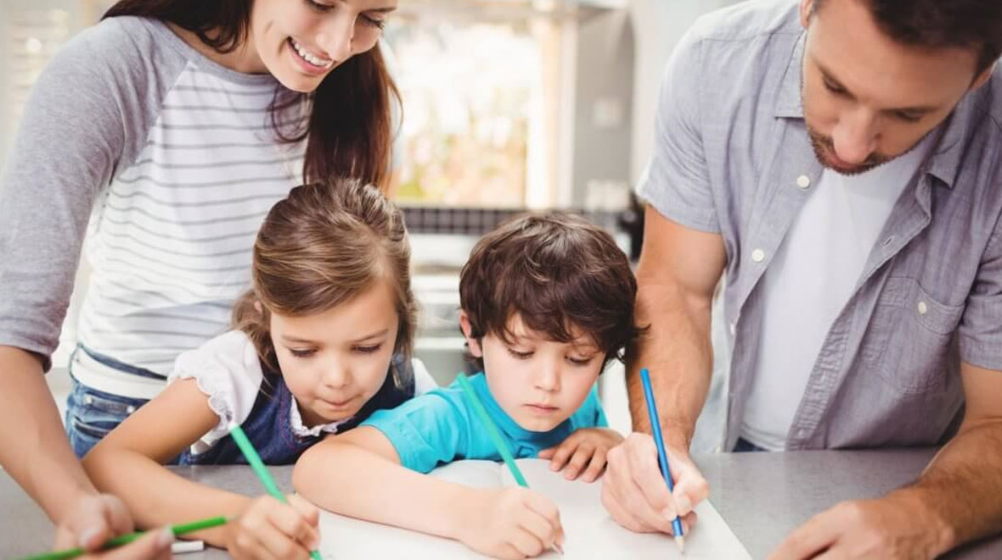

**This research paper explores the critical issue of gender equality and equity in children’s education. It provides a comprehensive analysis of current progress, challenges, and strategies for improvement. Besides, it examines the current status of gender equality in children’s education and its differences in access, retention, and quality of education between boys and girls.**

**These challenges often create imbalances in educational opportunities, especially for girls in marginalized communities. Therefore, analyzing these factors, the research underscores the role of gender equality and equity in fostering educational inclusivity and breaking intergenerational cycles of poverty and discrimination.**

**In fact, addressing these issues requires a multifaceted approach. That is why this research discusses a number of strategies for promoting gender equity in children’s education. For example, governments and organizations can play a crucial role in implementing policies and programs that remove barriers as well as create a healthy environment for equal educational opportunities. Meantime, the research highlights successful initiatives and emphasizes the need for sustained efforts to address both structural and cultural obstacles. Likewise, the research also stresses the necessity of monitoring and evaluating educational programs to ensure sustained progress.**

**As a conclusion, this research paper underscores the importance of achieving gender equity in education as a pathway to broader social and economic development. By addressing disparities and promoting inclusivity, education systems can become a powerful tool for empowering all children, regardless of gender, and for building more equitable societies.**

"The child is a trust in the hands of his parents, and his pure heart is a precious jewel. If he is habituated to good and taught it, he grows up upon it and achieves happiness in this world and the next."

Imam Al-Ghazali